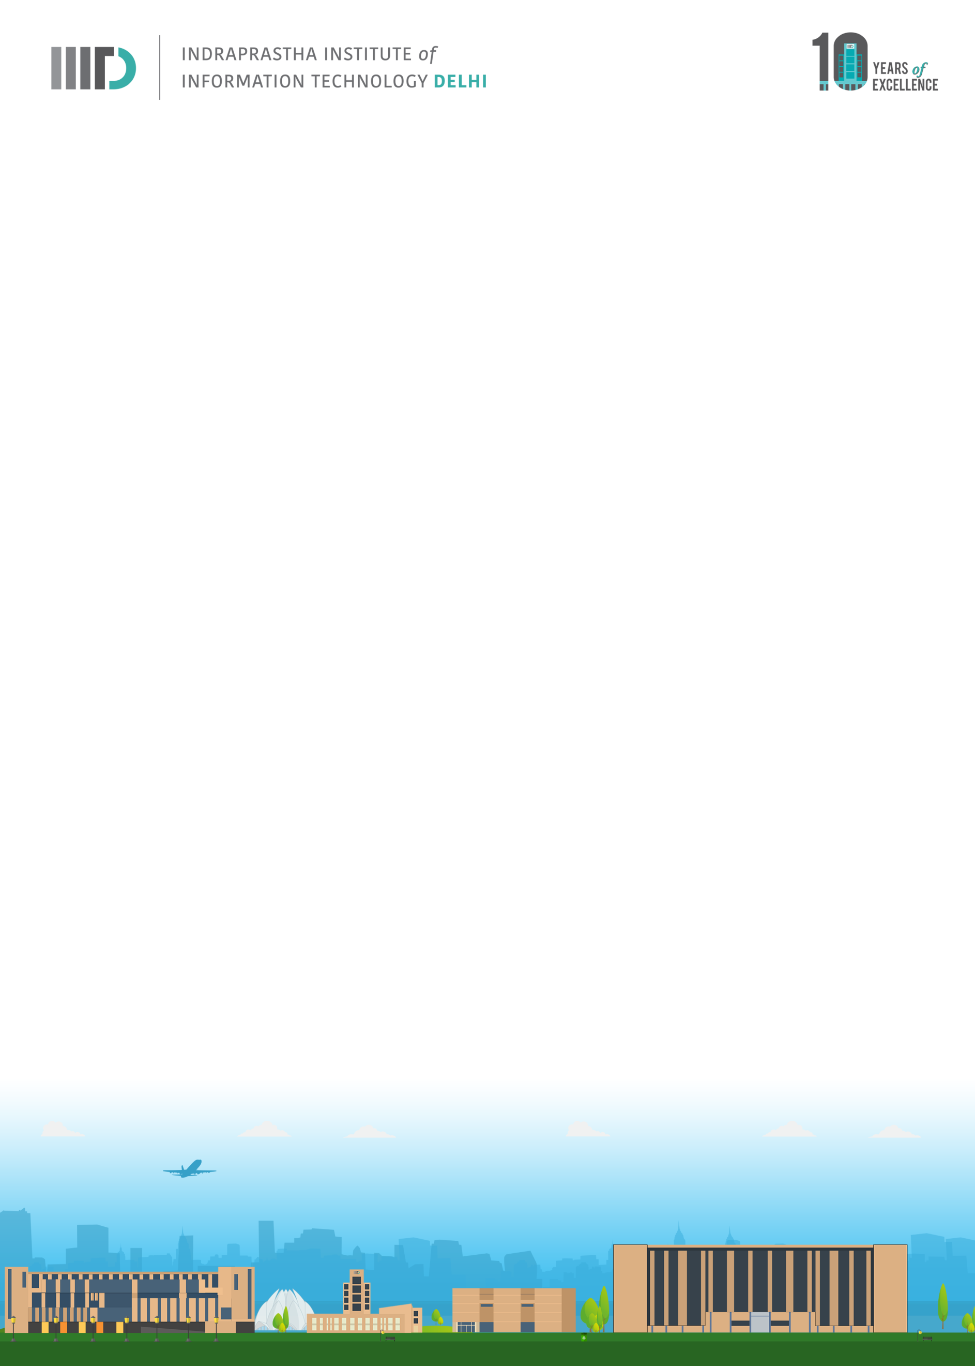

Invitation to M.Tech. Thesis Defense of Abhishek Goel: January 12, 2024 (Friday): 10:00 AM – 11:00 AM IST

In Partial Fulfillment of the Requirements for the Degree of
M.Tech. CB
Abhishek Goel (MT22197)
Will defend his thesis
Title: “Introducing the Health-Associated Core Keystone (HACK) index: A universal ranking order of gut microbial taxa for selection of next generation probiotic and biotherapeutics”
IIIT-D Faculty and Students are invited

Date: January 12, 2024 (Friday)
Time: 10:00 AM – 11:00 AM IST
Venue Details: A-320, 3rd Floor, R & D Building

Examiner:
Internal: G P S Raghava
External/Internal: Jaspreet Kaur Dhanjal
Advisor: Tarini Shankar Ghosh
Co-Advisor NA

*******************************************************
Abstract

Microbiome restoration has been considered as the potential therapeutic strategies for many diseases. As of now the focus has been done on identifying and administering specific microbes associated with health and administering either single or consortia of these microbes as probiotics or biotherapeutics, initially driven by observations of certain microbes being associated with health across multiple diseases. However, variations in baseline composition of 'healthy' microbiome across demographics and recent conflicting associations of some promising probiotics like Akkermansia muciniphila with diseases have highlighted the limitations of strictly compartmentalizing microbes as good or bad. This complicates the process of selecting microbiome therapeutic targets. In addition, most methods of selecting next generation probiotics and biotherapeutics have ignored two key properties that are required for a species to survive in an ecosystem, influence and stability.

To address, in this study we adopted a different approach where instead of compartmentalizing the taxa into good or bad, we for the first time build gut microbial species-scoring index that ranks 196 taxa, called the Health-Associated Core Keystone (HACK) index, by quantifying their association with three key hallmark properties, namely microbiome influence, stability association and health association. To develop this ranked score, we took performed a meta-analysis of publicly available 39,936 adult microbiomes (> 18 years) from 127 different study cohorts spanning 42 countries and 28 disease conditions. We also included 9,434 microbiomes to investigate the stability-association of the taxa in the gut microbiome. We identified set of 18 taxa, which we referred as the HACKs of the adult human gut microbiome, that have scores in the top 30 percentile with respect to all the three properties.

The HACK Score can potentially provide the new set of next generation probiotics. We can take the group of high HACK scoring taxa and customize them to rectify the microbiome dysbiosis. Not only it can help with finding the important gut microbes responsible to upkeep the gut health but it can also be used to grade donor microbiomes in cases of Fecal microbiome transplantation.

